Strategy Parameters
- Stock Purchase Price = $100
- Call Strike Price = $105
- Premium Received = $3

Methodology: The profit/loss of the long stock position and short call option position was calculated for stock prices ranging from $70 to $130 at expiration. The net payoff was obtained by combining both positions and plotted using Python.

Results:
Breakeven Price = $97
Maximum Profit = $8 per share
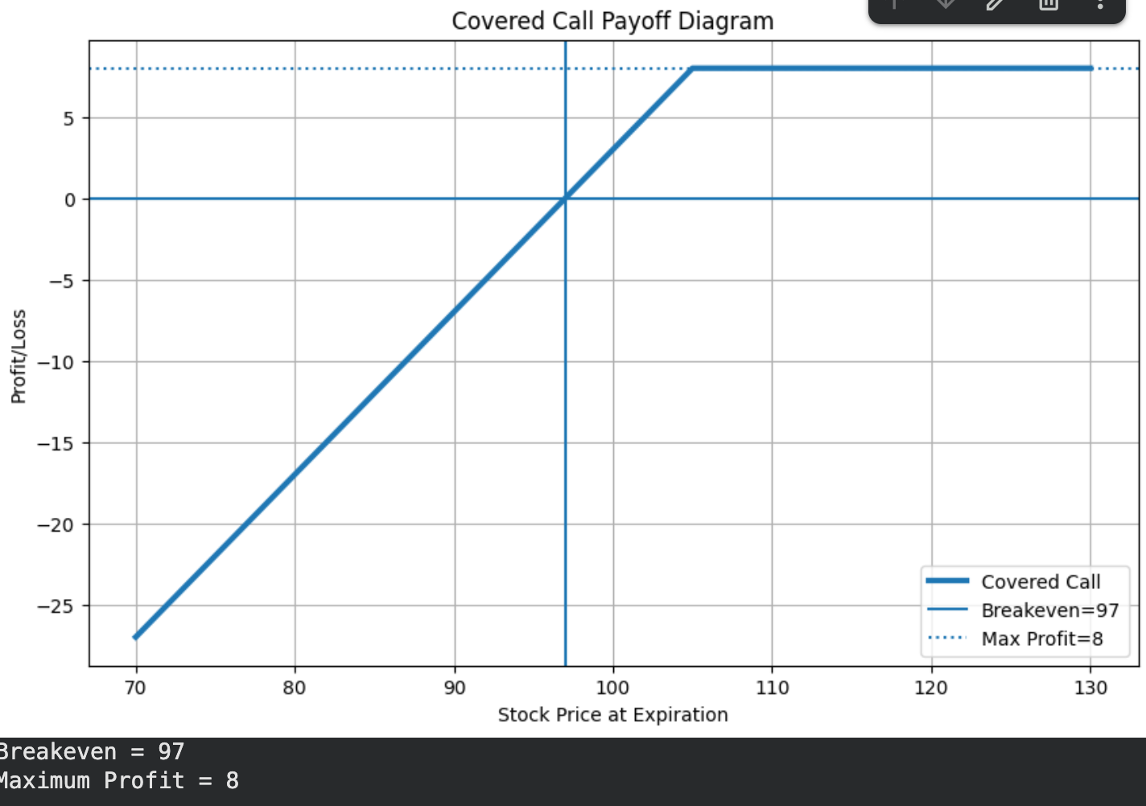

Conclusion: The Covered Call strategy generates income through the option premium while reducing the breakeven point to $97. The maximum profit is capped at $8 per share once the stock price reaches the strike price. Although the premium provides limited downside protection, the strategy still carries risk if the stock price falls significantly.

